Table of Contents
1. Introduction
2. Problem Analysis
3. Design Requirements
4. Possible Solutions
5. Preliminary Design (Flowchart)
6. Design Description
7. Software Simulation / Source Code
8. Experimental Results
9. Performance Analysis
10. Conclusion
11. References

1. Introduction
Embedded systems are microcontroller-based systems designed to perform dedicated, real-time functions within a larger application. The TM4C123GH6PM microcontroller by Texas Instruments is a 32-bit ARM Cortex-M4 device integrating rich on-chip peripherals including GPIO, UART, ADC, PWM, SSI, and hardware timers. It is widely used in embedded systems education due to its rich feature set, extensive documentation, and low cost.
This Open-Ended Lab (OEL) experiment targets the design and implementation of a Smart Power Monitoring Station on the TM4C123G LaunchPad. The system simulates a continuously varying analog voltage and implements real-time monitoring, visual alerting, and user-controlled arming using GPIO and UART peripherals operated entirely through polling-based logic. Three fundamental embedded concepts are exercised: serial communication via UART, digital I/O control through GPIO, and software-driven decision making.
UART (Universal Asynchronous Receiver-Transmitter) enables serial data exchange between the microcontroller and a PC terminal at a configured baud rate. GPIO (General Purpose Input/Output) pins are used here to drive an RGB LED for visual status and to sample push button SW1 for user input. Polling is a synchronous technique where the CPU repeatedly reads hardware register flags instead of waiting for interrupt service routines. Mastering these concepts prepares students for industrial embedded applications such as sensor monitoring nodes, control panels, and automated alert systems.

2. Problem Analysis
The problem asks for a Smart Power Monitoring Station that performs four integrated tasks: (1) maintains a software-simulated voltage variable that sweeps continuously from 0.00V to 3.30V and back; (2) transmits every voltage reading to a PC terminal via UART in real time; (3) allows the operator to arm or disarm an alarm system using push button SW1; and (4) controls an RGB LED to provide clear visual feedback based on both the system state and the current voltage level.
Voltage thresholds define three distinct zones: Critical Low (voltage below 1.0V), Normal/Safe Range (1.0V to 3.0V), and Critical High (voltage above 3.0V). When the system is armed, any voltage reading outside the safe range — whether a Critical Low or a Critical High — constitutes a fault condition that must trigger the Red LED alarm. When the system is disarmed, the Blue LED remains lit regardless of the voltage level, indicating standby mode.
The primary technical challenges are: correct initialization of multiple hardware peripherals using direct register manipulation without relying on any driver library; implementing button debouncing in a polling-only system; designing conditional LED logic that simultaneously respects both the armed flag and the voltage thresholds; and ensuring the UART transmit FIFO is not overflowed during rapid back-to-back character transmissions.

3. Design Requirements
The design is governed by the following requirements:
- Voltage Simulation: A floating-point variable must sweep 0.00V to 3.30V and back in increments of 0.05V per main loop iteration, creating a continuous triangular waveform that traverses all three voltage zones repeatedly.
- UART Communication: UART0 must be initialized at 115200 baud rate using Port A pins PA0 (RX) and PA1 (TX). Each iteration must transmit the string "Voltage=X.XX V\r\n" to the Tera Term terminal.
- GPIO Initialization: Port F must be configured with PF1 (RED LED), PF2 (BLUE LED), and PF3 (GREEN LED) as digital outputs, and PF4 (SW1) as a digital input with internal pull-up resistor enabled. The port unlock sequence is required because PF4 is a locked pin on this device.
- Arm/Disarm Toggle: Pressing SW1 (PF4, active-low) must toggle the armed flag. The button state must be detected by reading GPIO_PORTF_DATA_R masked with 0x10, followed by a debounce delay.
- LED Visual Feedback: Three clearly distinct states must be indicated — Blue LED solid when Disarmed; Green LED solid when Armed and voltage is in the safe range [1.0V, 3.0V]; Red LED blinking when Armed and voltage is in the Critical Low zone (<1.0V) or Critical High zone (>3.0V).
- Polling Only: All hardware synchronization must use polling — TXFF flag for UART readiness, PRGPIO flag for GPIO clock readiness, and direct GPIO register reads for button input. No interrupts are permitted.

4. Possible Solutions
Solution 1: ADC-Based Physical Voltage Monitoring
Use the TM4C123G ADC0 module to sample a real analog voltage from pin PE3 (AIN0) supplied by a potentiometer or resistive voltage divider on a breadboard. The ADC conversion formula V = (ADC_result / 4095) x 3.3V translates the 12-bit result to volts. This approach adds real-world sensing and exercises the ADC peripheral. However, it requires external hardware components, careful circuit setup, and additional ADC initialization and polling code, increasing overall complexity.
Solution 2: Software-Simulated Voltage — Selected
Use a floating-point variable incremented and decremented in software to simulate the voltage signal sweeping between 0V and 3.3V. No external circuit is required. The simulated waveform still exercises all the required system behaviors — UART transmission, threshold comparison, button polling, and LED control — identically to the ADC approach. The triangular sweep guarantees that every voltage zone (Critical Low below 1.0V, Normal 1.0V–3.0V, Critical High above 3.0V) is visited on every full cycle, enabling complete and repeatable testing of the fault detection logic.
This solution was selected because it isolates and demonstrates the core lab objectives without introducing hardware variability, making results fully reproducible.

Criterion | Solution 1 (ADC) | Solution 2 (Software)
Hardware Needed | Breadboard + Potentiometer | None (LaunchPad only)
Complexity | High | Low
Reproducibility | Variable | Fully consistent
Peripheral Coverage | ADC + UART + GPIO | UART + GPIO
Fault Zone Testing | Depends on user adjustment | Automatic (triangular sweep)

5. Preliminary Design (Flowchart)
The program follows a single infinite polling loop. The flowchart below describes the complete execution flow:

START
Initialize Port F (GPIO: LEDs + Button)
Initialize UART0 at 115200 Baud (Port A)
Set voltage=0.0, direction=+1, armed=0
---------- MAIN LOOP (repeats forever) ----------
voltage += direction x 0.05
If voltage >= 3.3V --> set direction = -1
If voltage <= 0.0V --> set direction = +1
Transmit "Voltage=X.XX V" via UART0
Poll SW1 (PF4): if LOW --> toggle armed flag + Delay (debounce)
If armed = 0 --> Blue LED ON (Disarmed)
If armed = 1 AND 1.0V <= voltage <= 3.0V --> Green LED ON (Normal)
If armed = 1 AND voltage < 1.0V (Critical Low)
OR voltage > 3.0V (Critical High) --> Red LED BLINKS
Delay (~50 ms pacing)
Return to top of MAIN LOOP

Each row represents either an operation or a decision point in the main loop. The three LED states map directly to the three system conditions: Disarmed (Blue), Armed-Safe (Green), and Armed-Fault (Red blink). The fault condition covers both Critical Low (<1.0V) and Critical High (>3.0V) under the same Red LED response.

6. Design Description
6.1 Port F GPIO Initialization — PortF_Init()
Port F is the GPIO port housing the on-board RGB LED (PF1=RED, PF2=BLUE, PF3=GREEN) and push buttons (PF4=SW1). Initialization starts by enabling the Port F clock through SYSCTL_RCGCGPIO_R bit 5, then polling SYSCTL_PRGPIO_R until the port signals readiness. Because PF0 and PF4 are locked pins (shared with NMI on this device), the unlock key 0x4C4F434B is written to GPIO_PORTF_LOCK_R and then GPIO_PORTF_CR_R is set to 0x1F to commit all five pins for configuration. GPIO_PORTF_DIR_R = 0x0E makes PF1–PF3 outputs and PF4 an input; GPIO_PORTF_DEN_R = 0x1F enables digital function on all pins; GPIO_PORTF_PUR_R = 0x10 enables the internal pull-up on PF4 so that SW1 reads logic-high when not pressed.
6.2 UART0 Initialization — UART0_Init()
UART0 maps to Port A pins PA0 (RX) and PA1 (TX). Clocks for both UART0 and Port A are enabled simultaneously. UART0 is disabled (UART0_CTL_R bit 0 cleared) before altering baud-rate registers. With a 16 MHz system clock and a 115200 baud target: BRD = 16,000,000 ÷ (16 × 115200) = 8.68, giving integer part 8 (UART0_IBRD_R = 8) and fractional part ⌊0.68 × 64 + 0.5⌋ = 44 (UART0_FBRD_R = 44). UART0_LCRH_R = 0x70 sets 8-bit word length and enables the TX/RX FIFO. UART0_CTL_R = 0x301 re-enables UART plus TX and RX bits. Finally, PA0/PA1 are switched to alternate function (AFSEL) and their PCTL nibbles are set to 1 to route the UART signal.
6.3 UART String Transmission — UART0_OutString()
The function walks through a null-terminated character array. For each character it first polls bit 5 (TXFF) of UART0_FR_R (Flag Register); as long as TXFF is set the transmit FIFO is full and the code spins in place. Once TXFF clears, the character is written to UART0_DR_R. This guarantees no character is ever dropped, even during the fastest possible consecutive transmissions at 115200 baud.
6.4 Voltage Simulation and Fault Detection Logic
The main loop maintains a float voltage variable. Each iteration adds direction × 0.05 to the current value. When voltage reaches or exceeds 3.3V, direction is set to −1 (start decreasing); when it falls to or below 0.0V, direction resets to +1 (start increasing). This produces a continuous triangular waveform. The three voltage zones encountered are:
- Critical Low -- voltage < 1.0V: Red LED blinks (fault, system armed)
- Normal / Safe -- 1.0V to 3.0V: Green LED solid (armed) or no action (disarmed)
- Critical High -- voltage > 3.0V: Red LED blinks (fault, system armed)
Both Critical Low and Critical High trigger the same Red LED blink response, unifying the fault indication under a single visual cue regardless of the direction of the voltage fault.
6.5 Arm/Disarm Toggle and Debouncing
SW1 (PF4) is an active-low button (reads 0 when pressed due to the pull-up resistor). The main loop reads GPIO_PORTF_DATA_R and masks it with 0x10. If the result is zero, the armed integer flag is toggled using the XOR-equivalent expression armed = !armed, and a full Delay() call is executed immediately after to debounce the mechanical contact and prevent a single press registering multiple toggles.
6.6 Software Delay
Delay() uses a volatile countdown loop calibrated to approximately 50 ms at a 16 MHz clock. The volatile qualifier prevents the compiler optimizer from eliminating the loop as dead code. The delay serves three purposes: button debouncing, Red LED blink timing during fault conditions, and pacing the main loop to produce a readable voltage update rate on the terminal.
7. Software Simulation / Source Code
The complete C source code implemented on the TM4C123G LaunchPad is listed below. Inline comments explain each register operation:

#include <stdint.h>
#include <stdio.h>
#include "C:\ti\TivaWare_C_Series-2.1.4.178\inc\tm4c123gh6pm.h"

#define RED 0x02 // PF1
#define BLUE 0x04 // PF2
#define GREEN 0x08 // PF3
#define SW1 0x10 // PF4

void PortF_Init(void);
void UART0_Init(void);
void UART0_OutString(char *pt);
void Delay(void);

int main(void){
float voltage = 0.0;
int direction = 1; // 1=increasing, -1=decreasing
int armed = 0;
char buffer[30];
PortF_Init();
UART0_Init();
while(1){
// --- Simulate voltage (triangular wave 0.00V - 3.30V) ---
voltage += direction * 0.05f;
if(voltage >= 3.3f){ direction = -1; }
if(voltage <= 0.0f){ direction = 1; }

// --- Transmit reading over UART ---
sprintf(buffer, "Voltage=%.2f V\r\n", voltage);
UART0_OutString(buffer);

// --- Poll SW1 to Arm / Disarm ---
if((GPIO_PORTF_DATA_R & SW1) == 0){
armed = !armed;
Delay(); // debounce
}

// --- LED logic based on armed state and voltage ---
if(armed){
GPIO_PORTF_DATA_R = GREEN; // default: armed & normal
if(voltage < 1.0f || voltage > 3.0f){
// FAULT: Critical Low (<1.0V) or Critical High (>3.0V)
GPIO_PORTF_DATA_R = RED;
Delay();
GPIO_PORTF_DATA_R = 0x00;
Delay();
}
} else {
GPIO_PORTF_DATA_R = BLUE; // disarmed
}
Delay(); // loop pacing ~50ms
}
}

void PortF_Init(void){
SYSCTL_RCGCGPIO_R |= 0x20; // enable Port F clock
while((SYSCTL_PRGPIO_R & 0x20)==0){}; // wait until ready
GPIO_PORTF_LOCK_R = 0x4C4F434B; // unlock Port F
GPIO_PORTF_CR_R = 0x1F; // commit all PF pins
GPIO_PORTF_DIR_R = 0x0E; // PF1-3 output, PF4 input
GPIO_PORTF_DEN_R = 0x1F; // digital enable all
GPIO_PORTF_PUR_R = 0x10; // pull-up on PF4 (SW1)
}

void UART0_Init(void){
SYSCTL_RCGCUART_R |= 0x01; // enable UART0 clock
SYSCTL_RCGCGPIO_R |= 0x01; // enable Port A clock
UART0_CTL_R &= ~0x01; // disable UART0 during config
UART0_IBRD_R = 8; // BRD integer (16MHz / 16 / 115200)
UART0_FBRD_R = 44; // BRD fraction (0.68 * 64 + 0.5)
UART0_LCRH_R = 0x70; // 8-bit, no parity, FIFO enable
UART0_CTL_R |= 0x301; // enable UART, TX, RX
GPIO_PORTA_AFSEL_R |= 0x03; // PA0/PA1 alternate function
GPIO_PORTA_DEN_R |= 0x03; // digital enable PA0/PA1
GPIO_PORTA_PCTL_R = (GPIO_PORTA_PCTL_R & 0xFFFFFF00) | 0x11;
}

void UART0_OutString(char *pt){
while(*pt){
while((UART0_FR_R & 0x20) != 0); // wait while TX FIFO full
UART0_DR_R = *pt++; // transmit character
}
}

void Delay(void){
volatile uint32_t time = 727240*100/91; // ~50ms at 16MHz
while(time){ time--; }
}

8. Experimental Results
The program was flashed onto the TM4C123G LaunchPad using Keil µVision and the output was observed via Tera Term (COM31, 115200 baud, 8-N-1). Six photographs document the observed behaviour across all system states and voltage zones:
Result 1 — Disarmed State: Blue LED
With the system powered on and SW1 not yet pressed (armed = 0), the Blue LED (PF2) illuminates solidly. This confirms that the GPIO output register is correctly driving PF2 with value 0x04, and that the arm-state default is disarmed. Voltage readings continue to be transmitted over UART during this state.
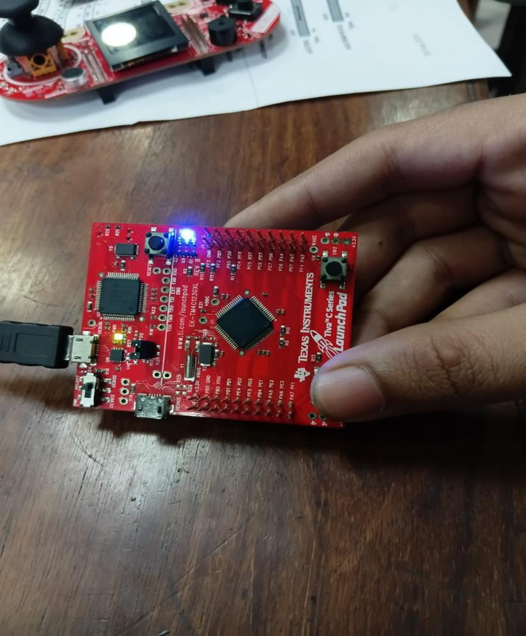
Figure 1: Blue LED ON — System Disarmed (armed = 0)
Result 2 — Armed State, Normal Voltage: Green LED
After pressing SW1 to arm the system (armed = 1), the Green LED (PF3) turns on solid whenever the simulated voltage is within the safe range of 1.0V to 3.0V. This confirms correct arm-state toggling and that the conditional LED logic accurately identifies the normal operating zone.
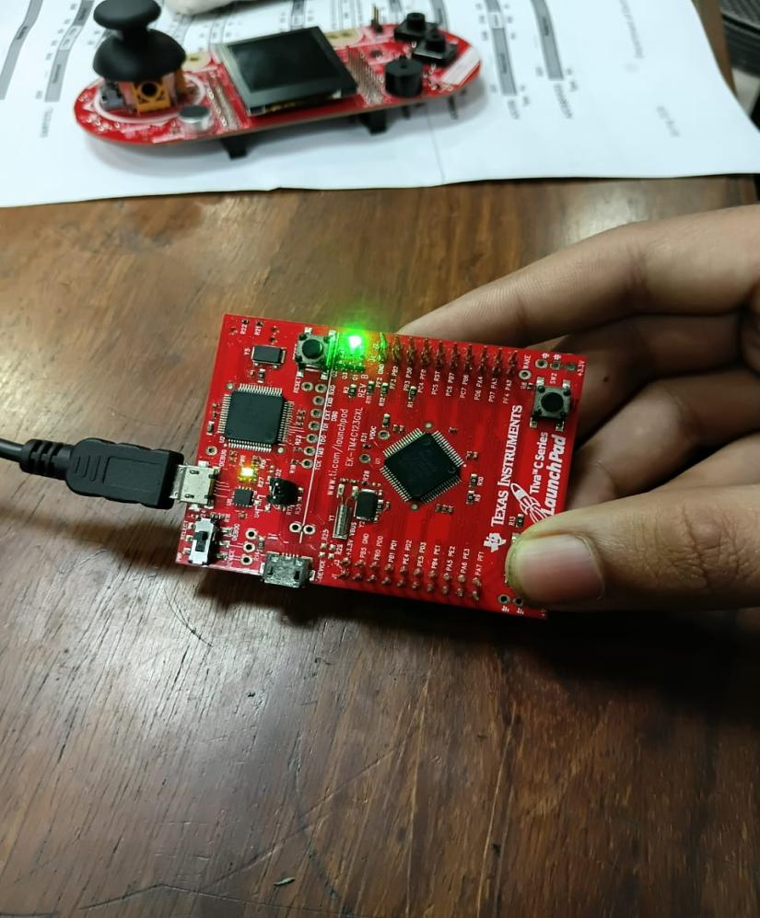
Figure 2: Green LED ON — System Armed, Voltage in Safe Range (1.0V – 3.0V)
Result 3 — Armed State, Voltage Fault: Red LED Blinking
When the system is armed and the simulated voltage enters either the Critical Low zone (below 1.0V) or the Critical High zone (above 3.0V), the Red LED (PF1) activates and blinks. The photograph captures the Red LED in its ON phase during one such blink cycle. This validates the fault-detection threshold comparisons and the blink implementation via paired Delay() calls.
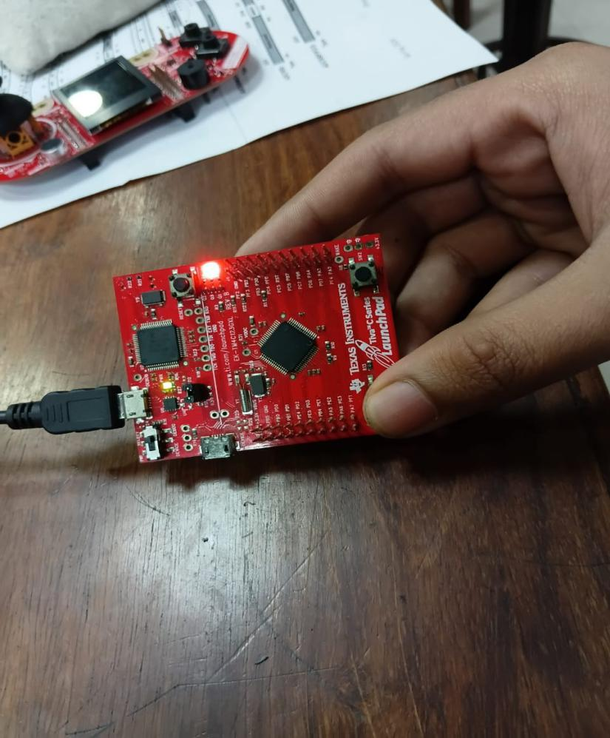
Figure 3: Red LED BLINKING — Armed, Fault Detected (Critical Low < 1.0V or Critical High > 3.0V)
Result 4 — Tera Term: Critical Low Zone (0.60V – 1.70V)
The terminal shows live voltage readings starting at 0.60V and rising through the Critical Low zone (0.60V–0.95V) and into the safe zone (1.00V and above). All readings are formatted exactly as "Voltage=X.XX V" with two decimal places. When armed, the Red LED blinks for every reading below 1.0V; when the voltage crosses 1.0V the system transitions to Green LED. This confirms accurate UART output and correct Critical Low threshold detection at exactly 1.0V.
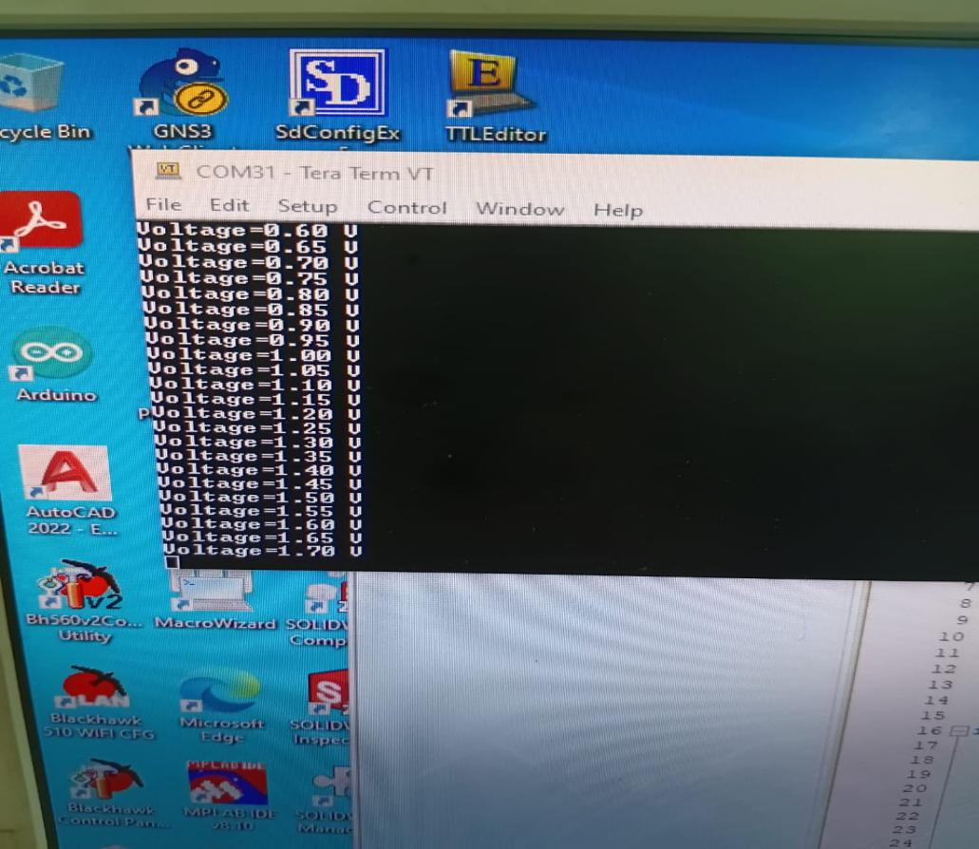
Figure 4: Tera Term — Voltage Rising from Critical Low Zone (0.60V) into Safe Zone
Result 5 — Tera Term: Safe Zone Sweep (0.75V – 1.85V)
This capture shows the voltage continuing its rise from 0.75V through 1.85V. The 1.0V threshold crossing is visible in the sequence, demonstrating the smooth, step-by-step 0.05V increments of the simulation. Above 1.00V the Green LED holds solid (when armed), confirming the boundary detection is evaluated correctly on every individual loop iteration.
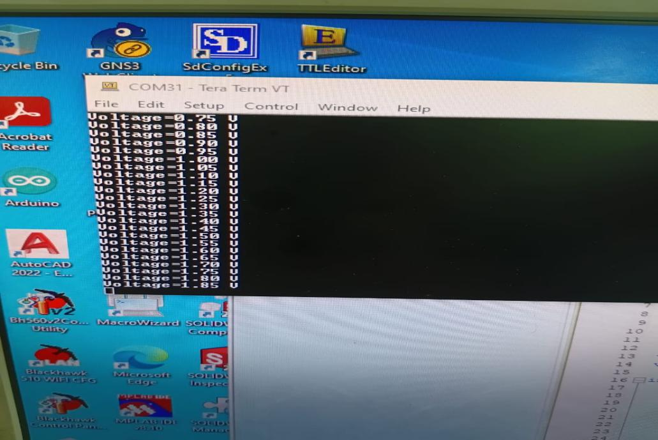
Figure 5: Tera Term — Voltage Sweeping Through Safe Zone (0.75V – 1.85V)
Result 6 — Tera Term: Critical High Zone (2.55V – 3.35V)
The terminal displays the voltage approaching the 3.0V upper threshold, crossing it, and climbing to 3.35V before reversing. Readings above 3.0V represent the Critical High zone: when armed, the Red LED blinks for each of these readings. The direction variable then flips to −1 at 3.3V and the voltage begins decreasing, completing one full triangular cycle. This confirms accurate Critical High detection and correct direction-reversal boundary logic.
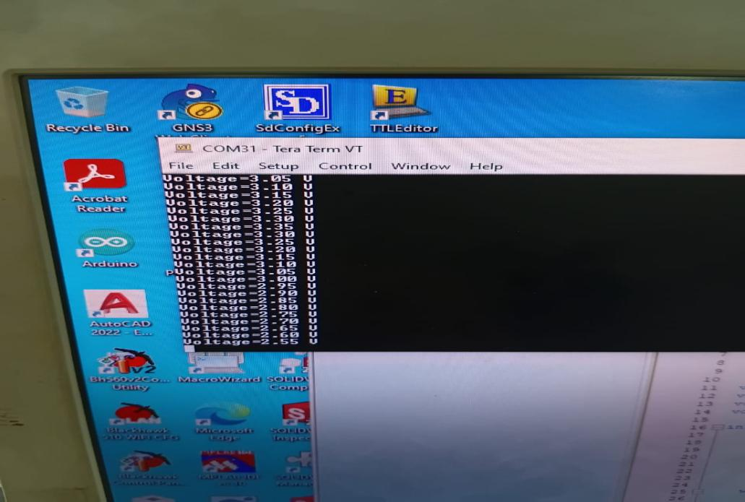
Figure 6: Tera Term — Voltage in Critical High Zone (above 3.0V), then Reversing

9. Performance Analysis
9.1 UART Communication
Voltage readings were transmitted continuously to Tera Term without any visible data loss or character corruption across all test runs. The "Voltage=X.XX V" format was consistent and accurate to two decimal places. The TXFF-polling approach in UART0_OutString() ensured the transmit FIFO was never overflowed even at the fastest iteration rate of the main loop. The ~50 ms per-iteration delay results in approximately 20 readings per second on the terminal — fast enough to observe the voltage sweep in real time while remaining human-readable.
9.2 Threshold Accuracy
The Critical Low threshold (below 1.0V) and Critical High threshold (above 3.0V) were both triggered at the correct step in the voltage sweep. Because voltage increments by exactly 0.05V, the boundary readings are 0.95V (last Critical Low) → 1.00V (first Safe) and 3.00V (last Safe) → 3.05V (first Critical High). The Tera Term output and LED behaviour confirmed these transitions at precisely the expected steps, with no off-by-one errors in either direction.
9.3 LED Visual Feedback
All three LED states (Blue, Green, Red-blink) operated correctly and distinctly. No unintended overlapping colours were observed. The Red LED blink period of approximately 100 ms (two back-to-back Delay() calls) was clearly visible and distinct from the continuous Blue and Green states. Bit-masking of GPIO_PORTF_DATA_R correctly isolated the target LED bits without affecting other Port F pins.
9.4 Button Polling and Debouncing
The SW1 button reliably toggled the armed state with a single press in every test. The software debounce delay eliminated false double-toggles caused by mechanical contact bounce. The state change was immediate upon button release from the polling perspective, with no noticeable latency to the user.
9.5 Limitations
The primary limitation is the use of software-simulated voltage rather than real ADC measurements, meaning the system does not demonstrate actual analog signal acquisition from a physical circuit. Additionally, the blocking Delay() calls mean the system is unresponsive during delay periods — a button press during a delay window will be missed. An interrupt-driven design would eliminate this limitation and allow genuinely concurrent handling of UART, GPIO, and timing events.

10. Conclusion
This Open-Ended Lab successfully demonstrated the design and implementation of a Smart Power Monitoring Station on the TM4C123G LaunchPad. The system integrated UART serial communication and GPIO peripheral control, managed entirely through polling, to achieve real-time voltage simulation, live telemetry output, user-controlled arming, and colour-coded visual alerting.
All design requirements were satisfied: UART0 transmitted correctly formatted voltage strings at 115200 baud; Port F GPIO drove the RGB LED accurately according to both system state and voltage zone; SW1 debounced arm/disarm toggling functioned correctly; and the fault detection logic precisely identified both Critical Low (voltage below 1.0V) and Critical High (voltage above 3.0V) conditions, triggering the Red LED blink alarm in both cases while keeping the Green LED lit during the normal safe range of 1.0V to 3.0V.
The experimental results, captured through Tera Term screenshots and hardware photographs, confirmed system behaviour across all voltage zones and both system states. The triangular voltage sweep provided a thorough and repeatable test of every operating condition without requiring external hardware. This experiment reinforced key embedded systems skills: direct-register peripheral initialization, bit-level GPIO manipulation, UART baud-rate calculation, polling-based synchronization, and software state-machine design.

11. References
- Texas Instruments, TM4C123GH6PM Microcontroller Data Sheet, Texas Instruments Inc., 2014.
- J. W. Valvano, Embedded Systems: Introduction to ARM Cortex-M Microcontrollers, 5th ed., 2014.
- Texas Instruments, EK-TM4C123GXL LaunchPad Evaluation Board User's Guide, Texas Instruments Inc., 2013.
- ARM Limited, Cortex-M4 Technical Reference Manual, ARM Limited, 2010.
- Keil MDK-ARM, µVision IDE Getting Started Guide, ARM Keil, 2020.

